

**Software Construction And Development**

**Final Project**

**BSSE-27 V A**

**Submitted By:**

**Usman Butt(12284)**

**Zohaib Hassan(12276)**

**Muhammad Huzaifah(12272)**

**Submitted To:**

**Ms. Fatima Gillani**

**Project Title:**

**E-Challan Management System**

Contents

E-Challan Management System 4

Introduction 4

Importance 5

Use Case Diagram 6

Descriptive Use cases 7

Descriptive Use Case 01: 7

Descriptive Use Case 02: 9

Descriptive Use Case 03: 11

Activity Diagrams 13

Activity Diagram 01: 13

Activity Diagram 02: 14

Activity Diagram 03: 15

Sequence Diagrams 16

Sequence Diagram 01: 16

Sequence Diagram 02: 17

Sequence Diagram 03: 18

Class Diagram 19

State Machine Diagrams 20

State Machine Diagram 01: 20

State Machine Diagram 02: 21

State Machine Diagram 03: 22

Deployment Diagram 23

Component Diagram 24

Petri Net Diagram 25

# E-Challan Management System

# Introduction

E-Challan is an online E-governance system to facilitate the traffic managers to manage the traffic violation as well as for the drivers to manage the penalties. E-Challan provides a wide range of support needed for managing and monitoring traffic penalties. It is also a type of decentralized information system which allows all the stakeholders to access the needed information anytime anywhere.

E-Challan Management System is a step forward approach about an e-Governance Management System. It allows stakeholders with different features i.e Challan, License Details, Vehicle Details and Challan Payment.

The Software allows to create and maintain a database containing information about different registered users, their license details and challans issued. The system also maintains a database of vehicles which are registered in the local RTO. This information can be used to verify drivers and in case of any violation of traffic rules to issue a challan to the driver. Also, the software allows the system administrator to access and update the databases when a new driver or vehicle is registered. The system admin also creates initial login credentials for the traffic department personnel. The administrator is the sole authority who can manipulate all the information in these databases.

# Importance

E-Challan Management System is very effective facility for the stakeholders like they can check there status at anytime and anywhere.

* If a Driver breaks a rule, then Traffic Police Personnel will issue him a Challan. Traffic Personnel will then upload Challan receipt in Portals Database. Then Driver at the spot can check Challan details as well as can make the payment and will get his license back.
* Before that System, There was a lot of hurdles for Driver like if Traffic Police issued him challan, then his license and Registration copy was transferred to the Police office, whenever he will pay the Challan he has to provide Payment receipt in office and then he will get back his license and vehicle copy.

# Use Case Diagram

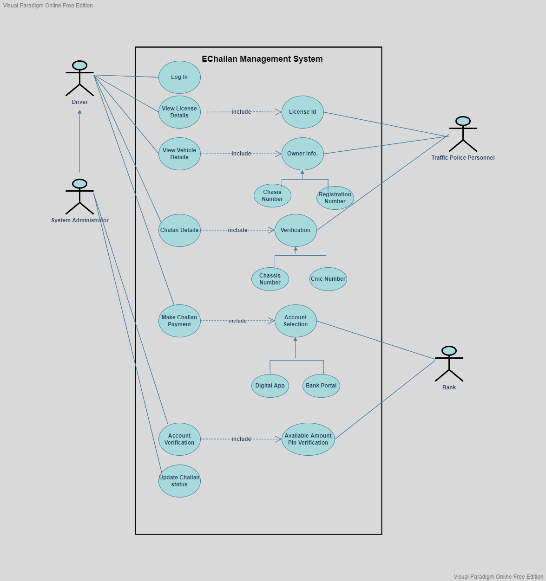

# Descriptive Use cases

## Descriptive Use Case 01:

|  |  |
| --- | --- |
| **UC-ID** | **03** |
| Name | Vehicle Details |
| Actors | Traffic Police Personnel, System. |
| Description | Traffic Personnel wants to check details of vehicle. |
| Pre-Condition | Verification of Registration Number and Chassis Number should be done. |
| Post-Condition | Details of Vehicle available. |
| **Main Success Scenario** | |
| **User Action** | **System Response** |
| 1.Traffic personnel will login to portal. | 2.System will ask for the login requirements. |
| 3. Traffic personnel will provide the requirements. | 4.System will make verification of requirements. |
|  | 5.System will ask for requirement again, if verification unsuccessful. |
|  | 6.System will give access to the portal after successful verification. |
| 7. Traffic personnel will select Vehicle Details. | 8.System will ask for Registration number and Chassis number. |
| 9. Traffic personnel will provide the requirements. | 10.System will then verify the requirements. |
|  | 11.System will proceeds to the log in panel again, if verification failed. |
|  | 12.System will then provide the details of the Vehicle, if verification is successful. |
| **Post-Condition:** Traffic Personnel gets vehicle details successfully. | |
| **Alternate Path:**  5.1: Provide authentic requirements i.e Username and password.  11.1: Provide correct details so that system can proceed. | |

## Descriptive Use Case 02:

|  |  |
| --- | --- |
| **UC-ID** | **04** |
| Name | Challan Details |
| Actors | Driver, System |
| Description | Driver wants to check details of Challan. |
| Pre-Condition | Verification of Cnic and Chassis Number. |
| Post-Condition | Details of Challan available. |
| **Main Success Scenario** | |
| **User Action** | **System Response** |
| 1.Driver will login to portal. | 2.System will ask for the login requirements. |
| 3.Driver will provide the requirements. | 4.System will make verification of requirements. |
|  | 5.System will ask for requirement again, if verification unsuccessful. |
|  | 6.System will give access to the portal after successful verification. |
| 7.Driver will select Challan Details. | 8.System will preview the requirements i.e: Cnic Number, Chassis Number. |
| 9.Driver will provide the requirements. | 10.System will then verify the requirements. |
|  | 11.System will proceeds to the log in panel again, if verification failed. |
|  | 12.System will then provide the details of the Challan, if verification is successful. |
| 13.Driver will get the details. | 14.System will generate the Challan receipt. |
| 15.Driver will get the Challan Receipt Copy. |  |
| **Post-Condition:** Driver will get the vehicle details successfully. | |
| **Alternate Path:**  5.1: Provide authentic requirements i.e Username and password.  10.1: Verification of requirements is successful then system will proceed.  11.1: Provide correct details so that system can proceed. | |

## Descriptive Use Case 03:

|  |  |
| --- | --- |
| **UC-ID** | **05** |
| Name | Challan Payment |
| Actors | Driver, System, Bank |
| Description | Driver will make payment of challan. |
| Pre-Condition | Verification of Bank account should be done. |
| Post-Condition | Successful Challan Payment. |
| **Main Success Scenario** | |
| **User Action** | **System Response** |
| 1.Driver will select the details of the Challan. | 2.System will ask for CNIC Number and Chassis Number. |
| 3.Driver will provide the specified requirements. | 4.System will verify the requirements. |
|  | 5.System will ask for requirement again if verification failed. |
|  | 6.System will then generate the Challan Details if verification successful. |
| 7.Driver will get the Challan Copy. | 8.System will then ask for make payment. |
|  | 9.System will preview the specified Payment accounts. |
| 10.Driver will select the account. | 11.System will ask for login requirements. |
| 12.Driver will provide the credentials. | 13.System will verify the credentials. |
|  | 14.System will ask for credentials again if verification failed. |
|  | 15.System will give payment option if verification is successful. |
| 16.Driver will select make payment. | 17.System will check either amount is available or not. |
|  | 18.System will give pop up(insufficient amount),if amount unavailable. |
|  | 19.System will then make transaction. |
|  | 20.System will then generate the transaction receipt. |
|  | 21.System will update the Driver’s Challan status. |
| **Post-Condition:** Challan Paid successfuly. | |
| **Alternate Path:**  2.1: Invalid entry in the requirement.  5.1: Provide authentic requirements i.e Username and password.  9.1: Invalid account selection.  11.1: Provide correct details so that system can proceed.  13.1: Invalid credentials provided.  17.1: Insufficient amount available. | |

# Activity Diagrams

## Activity Diagram 01:

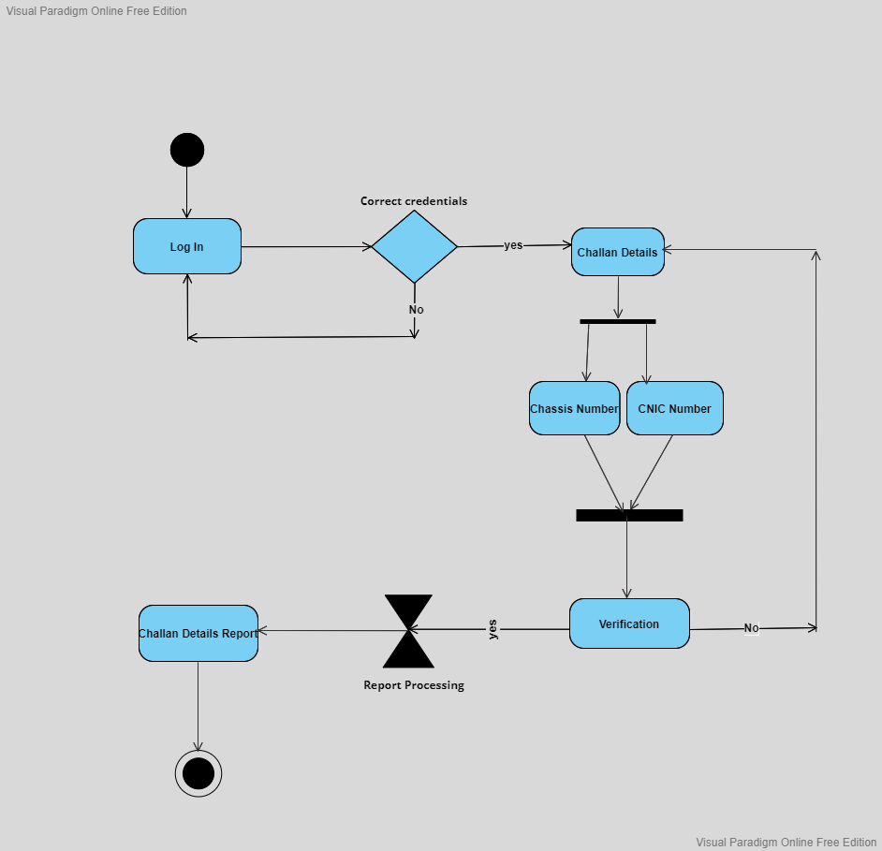

## Activity Diagram 02:

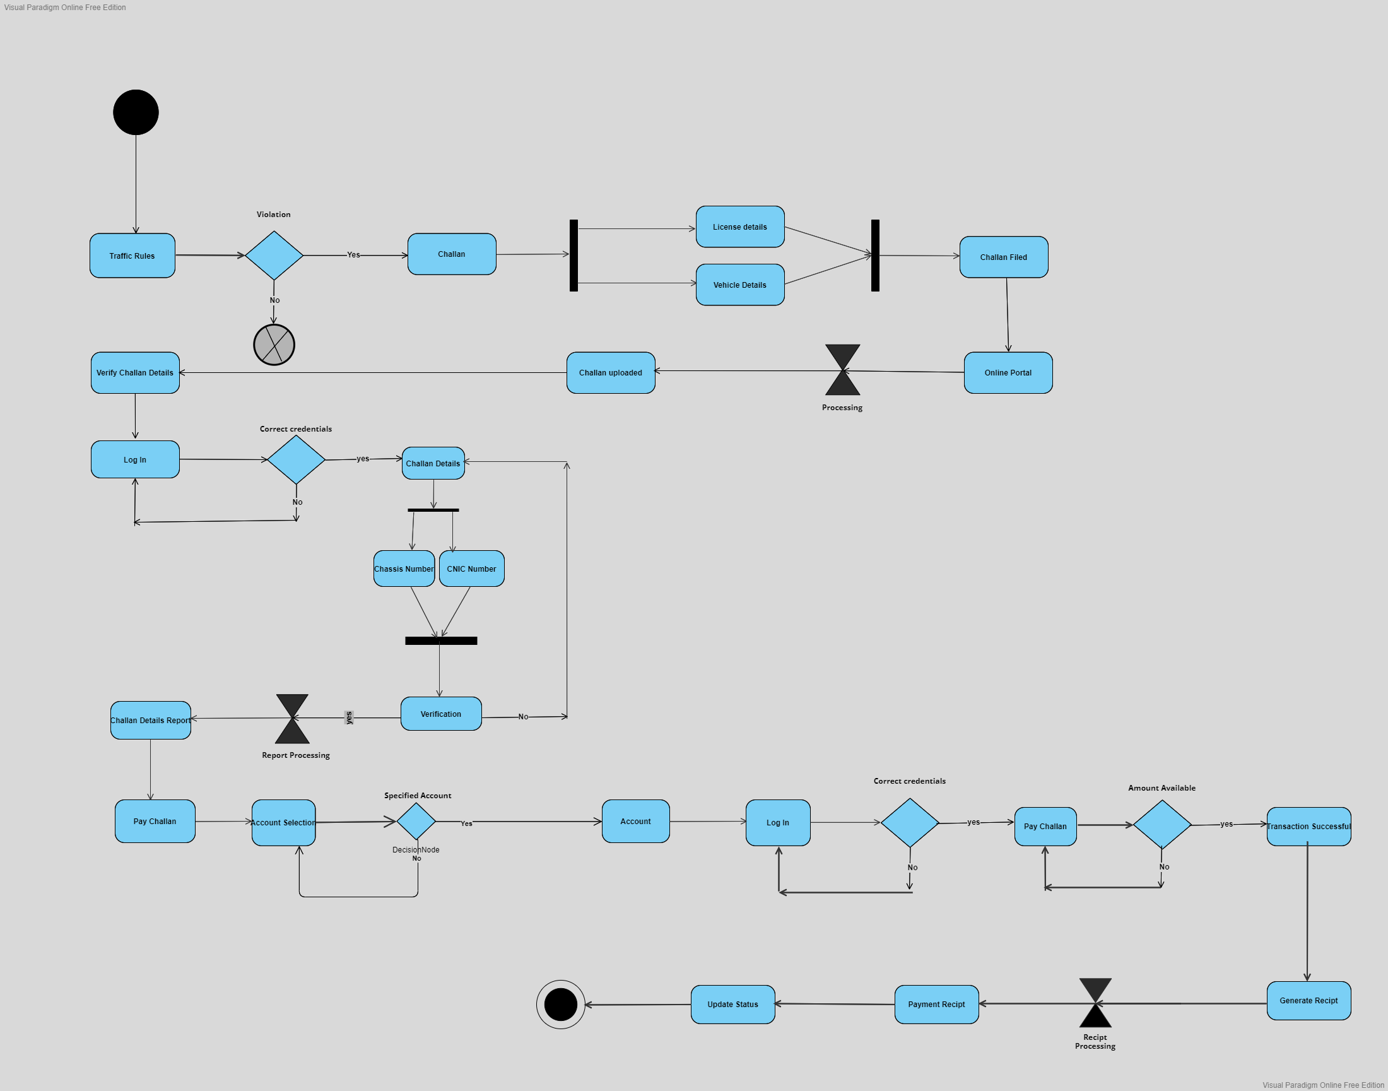

## Activity Diagram 03:

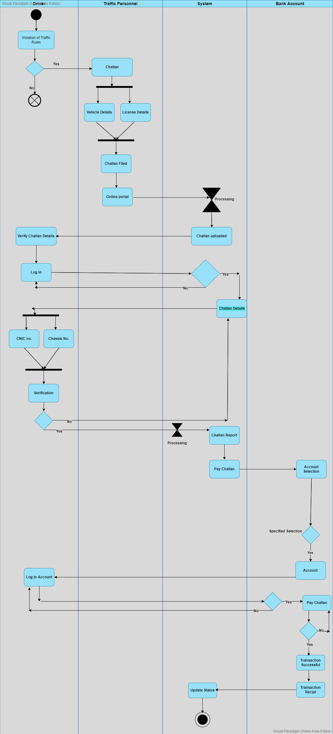

# Sequence Diagrams

## Sequence Diagram 01:

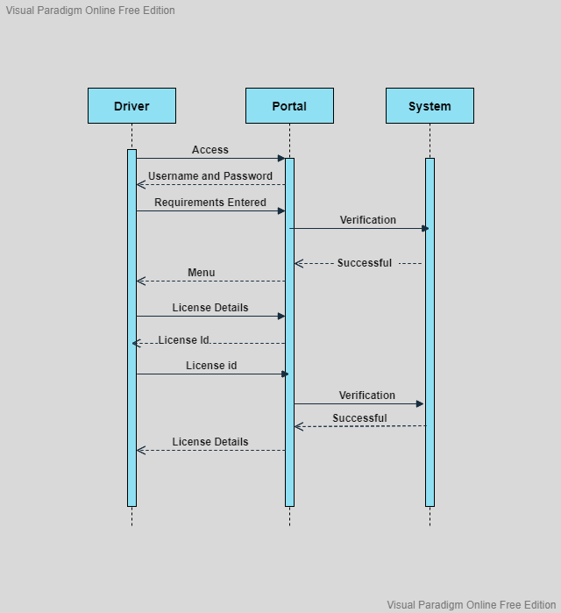

## Sequence Diagram 02:

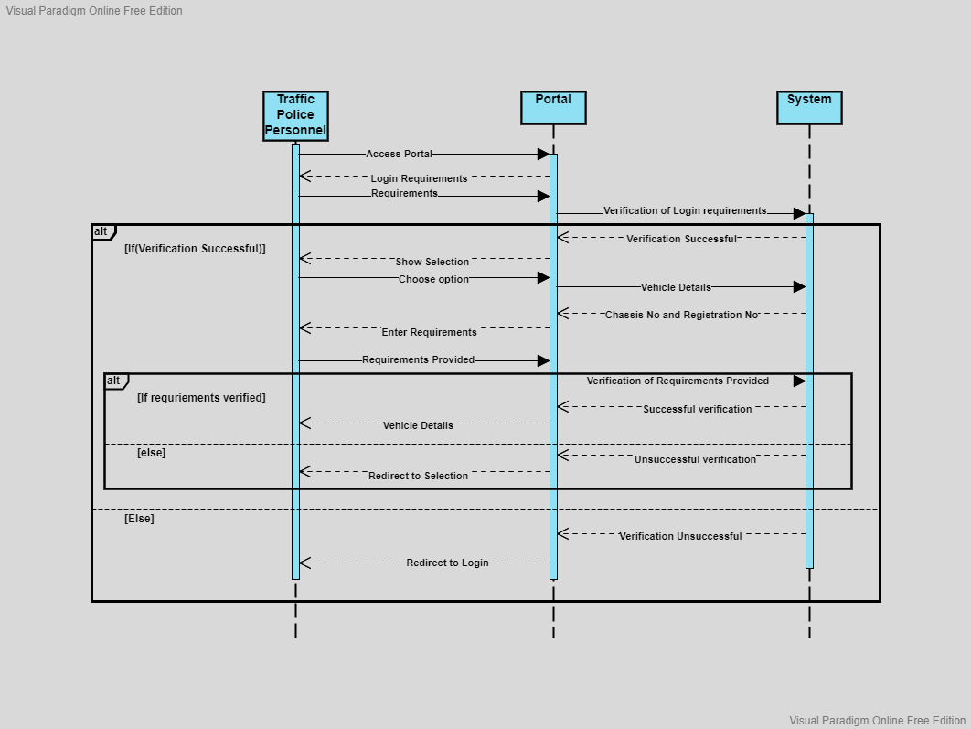

## Sequence Diagram 03:

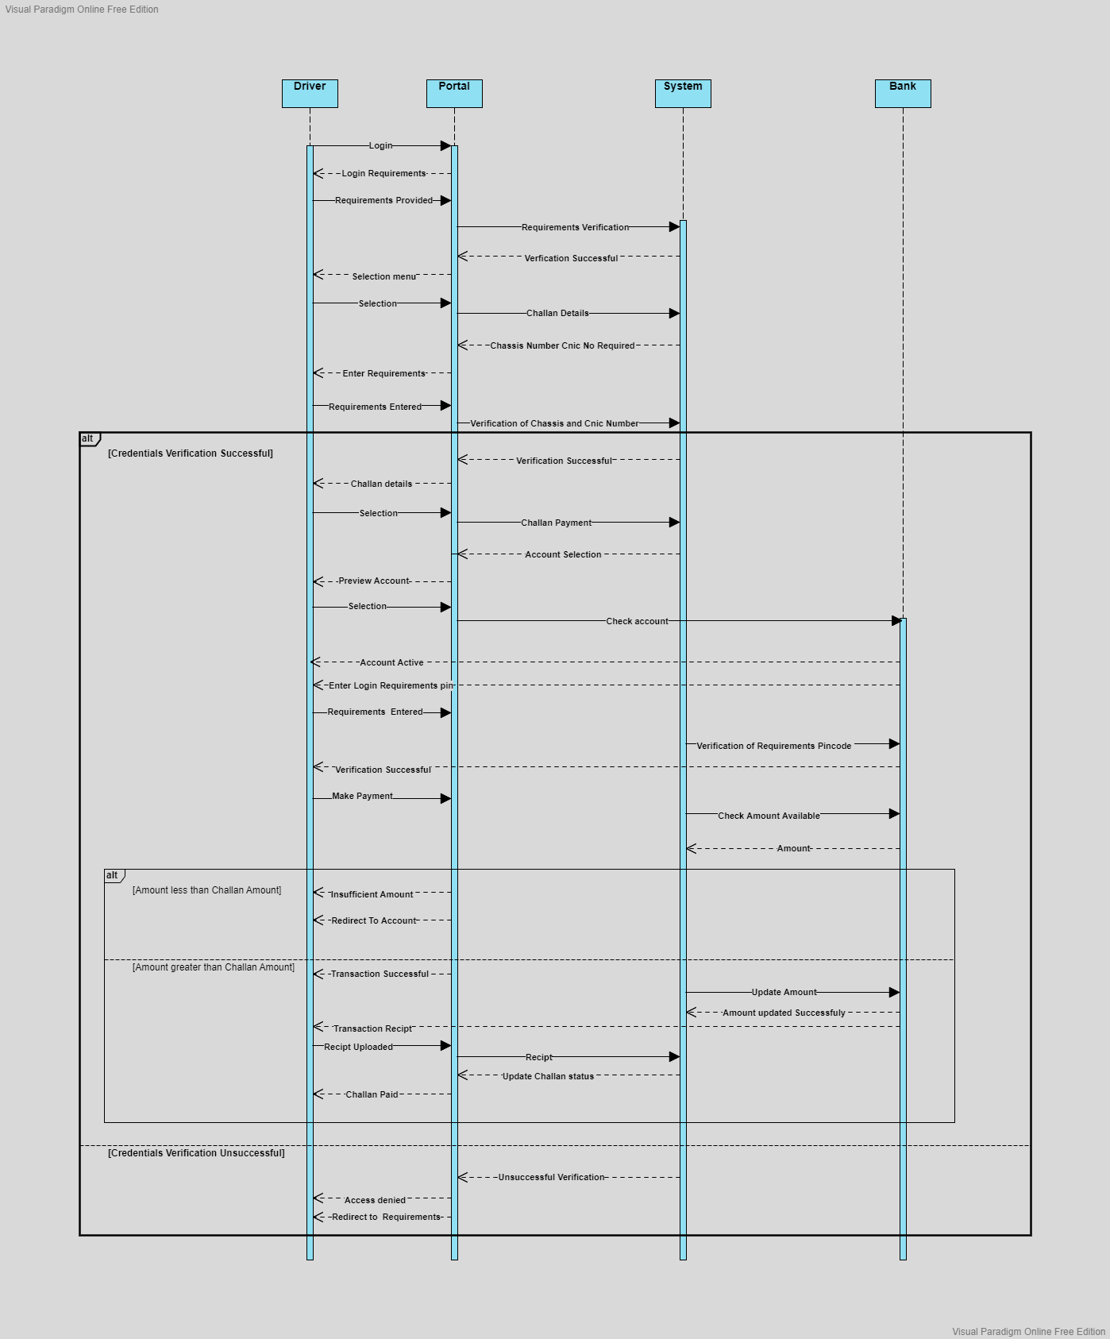

# Class Diagram

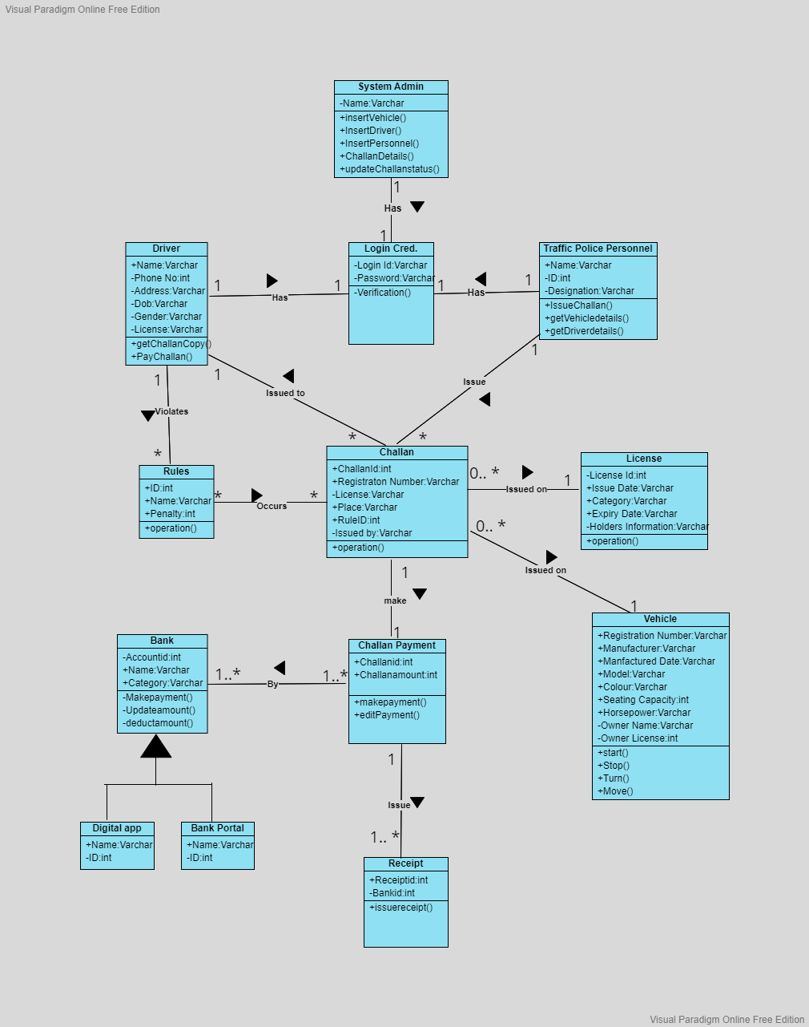

# State Machine Diagrams

## State Machine Diagram 01:

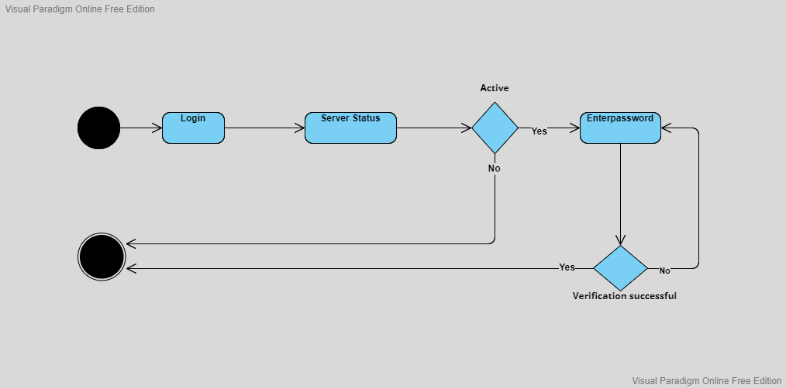

## State Machine Diagram 02:

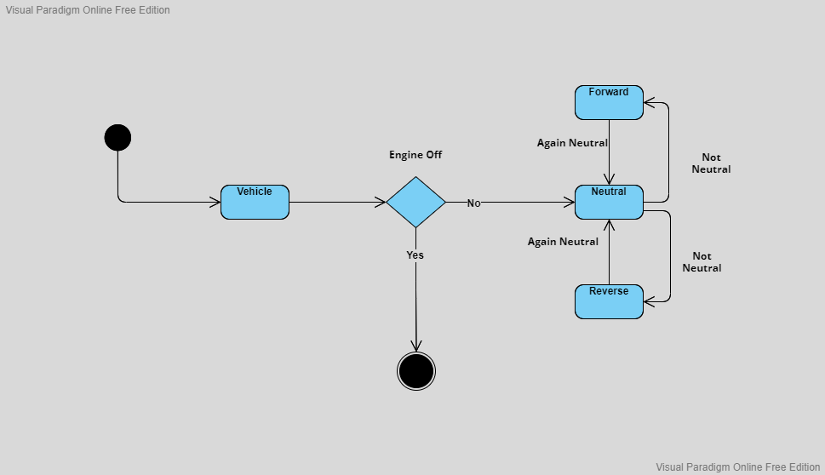

## State Machine Diagram 03:

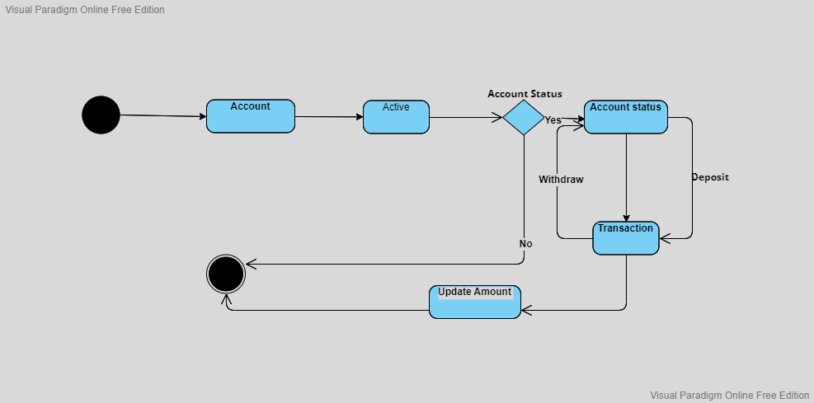

# Deployment Diagram

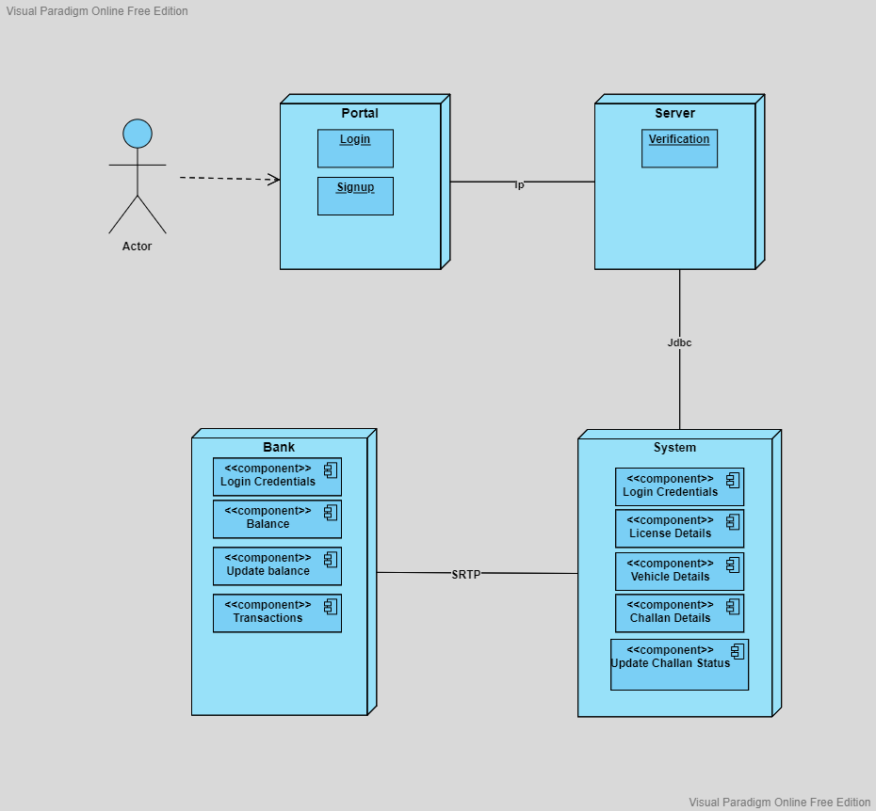

# Component Diagram

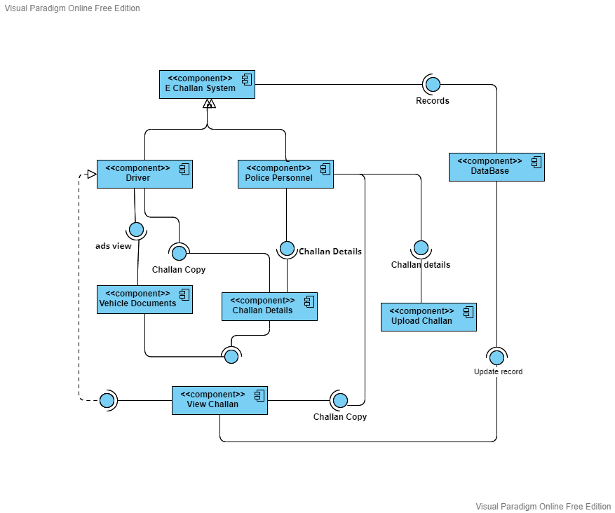

# Petri Net Diagram

